CTC Customer MDM Solution
Design Document
Segment Tracking in MDM

Phase 1

The official version of this document is stored online. Any hard copy versions of this document are for REFERENCE ONLY. Users of this document are personally responsible for using the official version, and for verifying that any copies are complete and of the official version.
Table of Contents

1 About the Document 4
1.1 Change History 4
1.2 Target Audience 4
1.3 References and Related Documents 4
1.3.1 References 4
1.3.2 Related Documents 4
2 Overview 5
2.1 Definitions, Acronyms and Abbreviations 5
3 Requirements 5
3.1 User Roles 6
4 Architecture Strategy 7
4.1 Assumptions 8
4.2 Constraints 8
4.3 Decisions 8
4.4 Alternate Approaches 8
5 Design Model 8
5.1 Design Overview 8
5.2 Data Model 9
5.2.1 Logical Data Model 9
5.2.2 Physical Data Model 10
5.2.3 Data Dictionary 10
5.2.4 Default Data 12
5.2.5 Dependent Code Table Values 12
5.2.6 Seed Data 12
5.3 API’s, External Interfaces and Semantics 12
5.3.1 addCTPartySegment (PartySegmentBObj, DWLControl) 12
5.3.2 addCTPartySegment (PartySegmentBObj, DWLControl) 13
5.3.3 updateCTPartySegment (PartySegmentBObj, DWLControl) 13
5.3.4 getAllCTPartySegment (PartySegmentBObj, DWLControl) 14
5.4 Error Handling 15
5.5 Performance Considerations 15
6 Unit Test Strategy 15
7 Packaging and Deployment 15
8 Administering the Feature 16
9 Usage Examples 16
9.1 User Interface 16
9.2 Web Services 16
10 Outstanding Issues 17
11 Appendix and References 17

About the Document

Change History
Summarize all changes to this document in the table below. Each revision (B) may go through several drafts (D) before it is approved. All draft entries are to be consolidated and summarized into one entry for the approved R. When the document is approved, the D numbers are dropped and the R number stands alone. When an approved document needs to be modified, a new document is created, the R number is incremented and the D number starts at 1 again. All previous R entries are kept in the new document.
Table 1: Document Change History
Revision | Date | Author | Summary of Change
R0D1 | 2011-09-05 | moo@infotrellis.com | Initial Draft
R0D2 | Yyyy-mm-dd |  | Describe changes or refer to MS Word track changes tool mark ups
R0D3 | Yyyy-mm-dd |  | More changes described here
R0 | Yyyy-mm-dd |  | Approved version of document
R1D1 | 2011-09-13 | Saravanan@infotrellis.com | Detailed design Draft
R1D2 | 2011-09-16 | Saravanan@infotrellis.com | Modified the flow diagram, added class and sequence diagram.
*Only use yyyy-mm-dd date convention.
*Use Word “track changes” for edits between reviews of each draft.

Target Audience
Architects
Business Systems Analysts
Developers
Development Managers
QA Engineers
Release Manager

References and Related Documents

References
<External books and articles if any>

Related Documents

CTC-MDM Functional Requirements

Overview
<Provide a brief overview of what the feature is, its general technical/business use and general impact on the product. This section should not include a description of the design at a high level or in detail. The design sections later in the doc should be used for design description.>
<Provide background, introduction or abstract for the new set of features being added or an existing feature/feature set being re-designed>
The Segment feature in MDM is to capture and display customer segment information. Customer segments are calculated through analysis of customer spending habits or trends (for example) in the data warehouse. There is a need to capture this information in the MDM hub and make it accessible to the enterprise. MDM will not be the source for Segment information, nor will be maintained in MDM except from delta loads.

Definitions, Acronyms and Abbreviations

Requirements
<This section is not intended to document the requirements. The purpose is to highlight requirements that have a significant impact on the design/architecture of this feature to help the reader understand the reasoning behind the design decisions.>
<Include reference to applicable Technical or Business Requirements document here so that readers can get the correct context for the feature design.>
Please refer to the CTC-MDM Functional Requirements document for details.
MDM shall enable the Customer Segmentation information from EDW/CAR to be loaded into the Customer Hub with the following information:
- Party ID (mandatory), which shall be a Party ID in the Customer Hub for whom the segmentation information is associated with
- Provider (mandatory), (e.g. CACE, dunnhumby) which performed the analytics
- Customer Group (mandatory), (e.g. CTR, CTP, Mark’s) for which the analytics was performed
- Segmentation Scheme (mandatory), (e.g. Shopping Habits, Deal Seekers) representing what was measured in the analytics
- Value (optional), (e.g. Premium, Valuable, Yes, No) which specifies the Segment where the Party belongs
- Last Calculated Date (mandatory), which shall specify the date when the analytics was run
- It shall be possible for a Party belonging to a particular Segment Value to be further categorized into a Segment Group.
  - For example, CACE uses the following Segment Values: 1 = Premium, 2 = Valuable, 3 = Potential, 4 = Occasional, 5 = Uncommitted. If a customer belongs to 1 = Premium or 2 = Valuable, that customer is further classified under the LOYAL Segment. If a customer belongs to 3 = Potential or 4 = Occasional, that customer is further classified under the OPPORTUNITY Segment.
  - Another example, dunnhumby uses the following Segment Values: 1 = Premium, 2 = Valuable, 3 = Potential, 4 = Occasional, 5 = Uncommitted. If a customer belongs to 1 = Premium or 2 = Valuable, that customer is further classified under the Loyal Segment. If a customer belongs to 3 = Potential or 4 = Occasional or 5 = Uncommitted, that customer is further classified under the Opportunity Segment.
- Updates to a Party’s existing segmentation information shall be allowed based on key information still to be defined.
- The business history of a Party’s segmentation information shall not be maintained in the Customer Hub, i.e. the Customer Hub shall have only the latest segmentation information as fed to it by the EDW/CAR.

User Roles
<If important to the feature design, provide reference(s) to the user roles that will use the feature described in this document. The purpose of these references should be to explain design decisions that were based on who the user is and/or how they will interact with the system.>

Architecture Strategy
< Describe high-level technical strategy for the module and how it fits into the overall MDM Architecture, including impacts on existing modules if applicable. Use pictures and diagrams as needed>
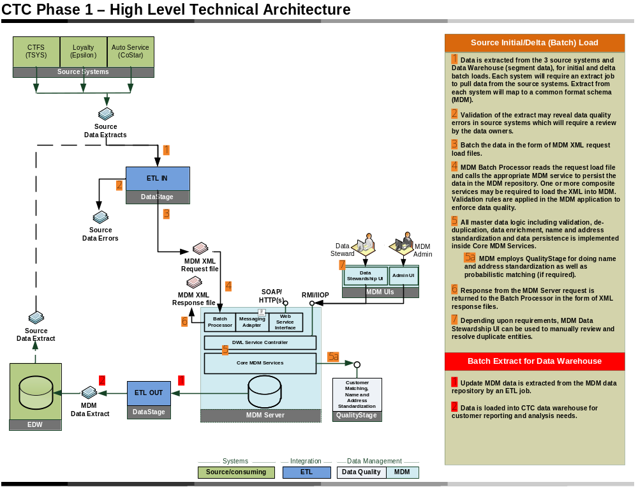Figure 1 – Overall Phase 1 CTC Conceptual Architecture
Extract Segment data from EDW to load into MDM
Services to maintain segment data in MDM

For the Segment feature, we are capturing a defined segment that is calculated in the EDW that we want surfaced in the MDM layer. Segment information provides additional information about the customer that we want to share across the enterprise.
There 2 areas of focus:
- EDW extract
- MDM services/repository to maintain customer segments

Assumptions
<List any assumptions, in any, being made for this design. Examples include availability of any open-source, other code or pre-requisite software, being used in this design.>
- Segments will not be maintained in the hub. Segments will only be added/updated into the hub through batch mode, or non-real time mode.
- Although a customer segment represents a point in time and there is no need for a customer segment business history, we will follow the established MDM pattern for keeping business history by ending a segment when it is no longer in effect.
- Segments will be calculated in the EDW and sent to MDM.
- No valid values validation for the fields segment_provider, business_group_name, segment_type_name, segment_value, segment_category_type. The values sent from EDW will be stored in the MDM
- EDW will be in sync with MDM party ID to perform the valid party segment add/update

Constraints
<Describe issues and challenges in designing and implementing the module. Identify possible ways to overcoming these challenges. Create your own sub-sections as needed>
Not applicable

Decisions
<List of decisions that have been made with regards to the design and/or implementation of the feature. Any changes to business requirements throughout the iteration should be kept track of here as well, dated with the decision-makers involved indicated for each.>
- Although a customer segment represents a point in time and there is no requirement to keep customer segment business history, we will follow the established MDM pattern for keeping business history by ending a segment when it is no longer in effect. It essentially achieves the same result with added flexibility.

Alternate Approaches
<Discuss any alternate approaches that were considered and a brief justification for selecting the current approach>

Design Model

Design Overview
<Paragraph giving an overview of the feature design and approach.>
<Use one or more class diagrams to show the major abstractions in the design and their relationships.>
<Briefly describe the behavior of the objects in this module, to show the collaborations among the objects. Either sequence diagram or collaboration diagram is ok, or you can have both here.>
<Use this section to discuss the basic construct of the design. If there is specific Use Case or a set of Use Cases this addresses, provide links for the same. Create your own sub-sections as needed based on the logical break-ups needed for the design being proposed. Use pictures and UML diagrams as needed. If the design crosses over multiples modules in the application use the main paragraph to talk about the overall design and use the sub sections to address module related design elements and use sub sections further to address each module’s sub section break up.>
<Discussion of error handling should also be included in this section. Should include significant error cases and how those should be handled/appear to the user.>
- ETL – From EDW to MDM – please see ETL Export to MDM for Segment design doc
- MDM – we will capture Customer segments in MDM by adding a new subject area to hold this. (ie: creating additions). There will be services to add/update/get customer segments.
CTC Add Party Segment
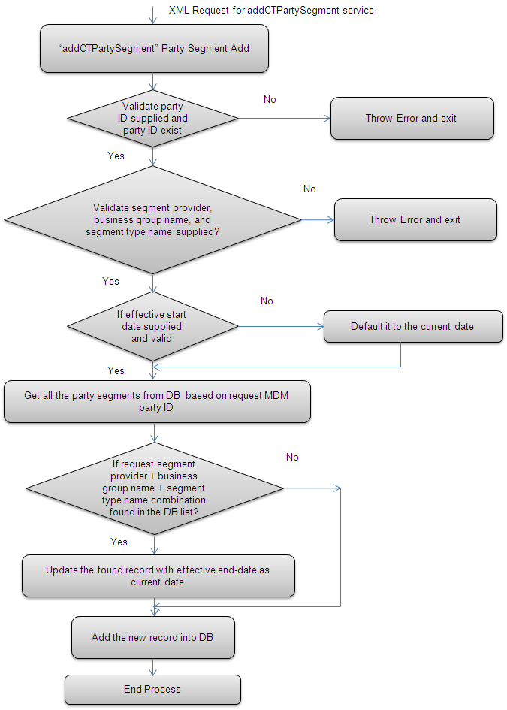

CTC Update Party Segment

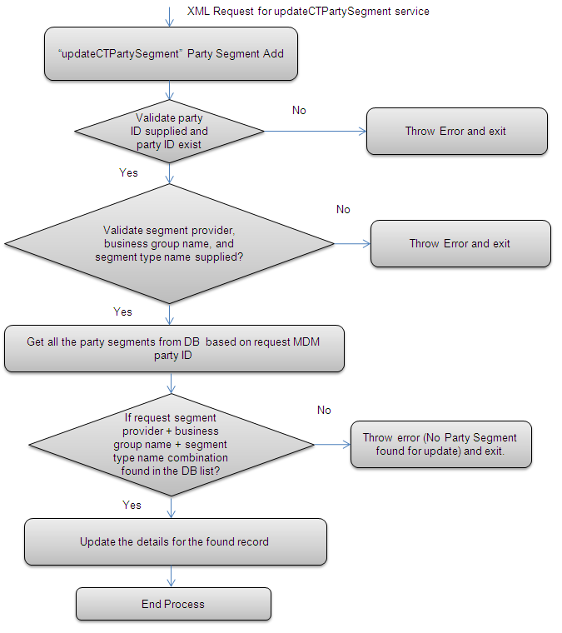

Implementation design

MDM Module project Entry – Data Addition

Field | Entry
Project Name | CTCAdditions
Base Java Package Name | com.ctc.mdm.addition
Service namespace URI | http://com.ctc.mdm.addition/
EAR project name | MDM

MDM Workbench Entry

Field | Entry
Select Project | CTCAdditions
Extension base name | CTCPartySegment
Controller base name | CTCPartySegment
Component base name | CTCPartySegment
Entity base name | CTCPartySegment
Database table name | CT_PARTYSEGMENT

Class Diagram
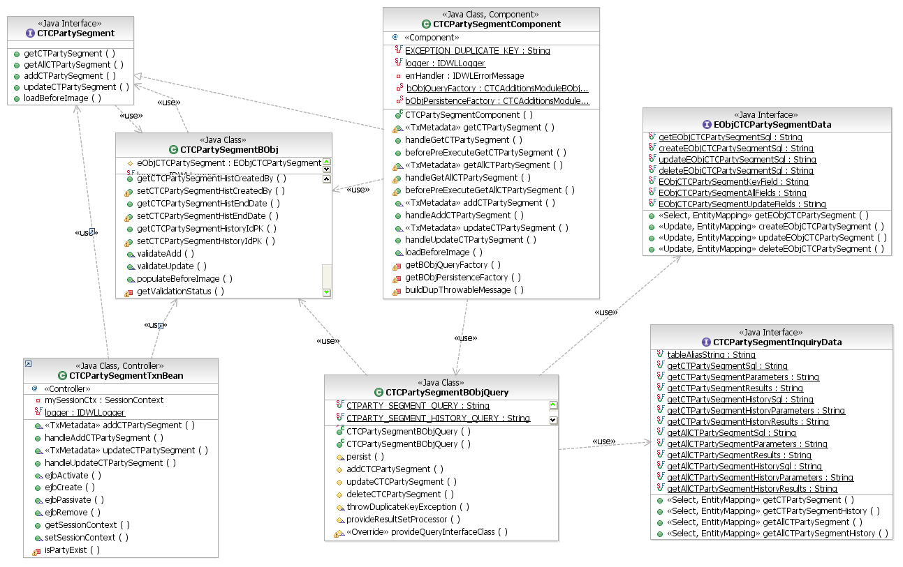

Sequence Diagram
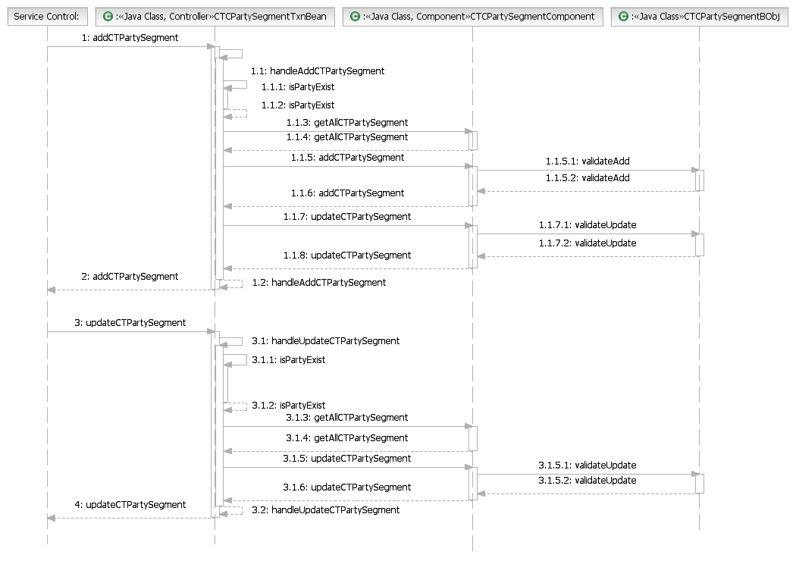

Data Model
<Provide a paragraph giving introducing the entities that will be included in the MDM data model.>

Logical Data Model
<Show the logical data model using one or more ER diagram(s) including all the relevant entities, their attributes, and the relationships. >
cust id | party id | Cust type | segment type | score | Grouping | Effective date

The above table view shows how dunhumby, one of possibly many systems that can generate customer segments will be sending MDM segment information.

<PartySegmentBObj>
<PartyId>
<Segment Provider>
<CT Business Type>
<Segment Type>
<Segment Score Value>
<Customer Segment Category>
<Effective Start Date>
<Effective End Date>
</PartySegmentBObj>

Physical Data Model
<Show the physical data model using one or more ER diagram(s) including all the relevant entities, attributes with proper data-types and “nullability” as well as the relationships >
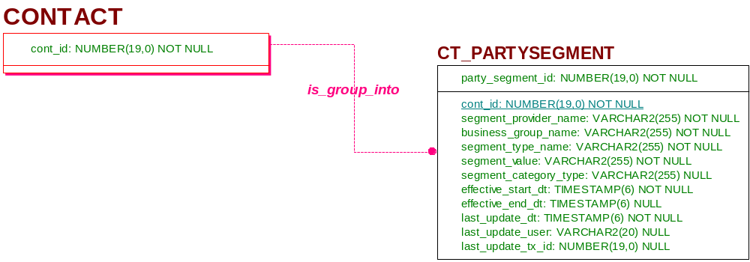

Data Dictionary

<Table Name>
Column Name | Comment | Data Type | Java Type | Null Option | Is PK
party_segment_id | A unique, system-generated key that identifies a party segment in the system. | Number (19,0) | java.lang.Long | Not Null | yes
cont_id | A unique, system-generated key that identifies a party in the system. | Number (19,0) | java.lang.Long | Not Null
segment_provider | The segment provider that derived or generated the segment score for the customer as it related to the business group. Eg: CACE, dunhumby | Varchar2(255) | java.lang.String | Not Null
business_group_name | The Canadian Tire group that this segment was derived from. Eg: CTFS. CTR, CTP | Varchar2(255) | java.lang.String | Not Null
segment_type_name | The assigned segement type for this Customer. It is derived from the EDW analytics engine. Eg: Shopping Habit, Deal Seeker | Varchar2(255) | java.lang.String | Not Null
segment_value | The assigned segment value for this Customer. It is derived from the EDW analytics engine. Eg: Premium Customer, Occasional Customer, “Yes” (Deal Seeker) | Varchar2(255) | java.lang.String | Null
segment_category_type | The categorization of the customer based on his segment value. Eg: Loyal, Opportunity | Varchar2(255) | java.lang.String | Null
effective_start_dt | The date when this Customer Segment record becomes into effect. | Timestamp(6) | java.sql.Timestamp | Not Null
effective_end_dt | The date when this Customer Segment record is no longer in effect. | Timestamp(6) | java.sql.Timestamp
last_update_dt | When a record is added or updated, this field is updated with the date and time. On subsequent updates, the system uses this information to ensure that the update request includes a matching date and time on this field; if it does not, the update fails. | Timestamp(6) | java.sql.Timestamp | Not Null
last_update_user | The ID of the user who last updated the data. | Varchar2(20) | java.lang.String
last_update_tx_id | A unique, system-generated key that identifies the specific transaction within the log system that either created, updated, or deleted the data row. | Number (19,0) | java.lang.Long

Default Data

Dependent Code Table Values
<List any code table values this feature will have a dependency on>

Seed Data
<Provide all new seed data (GOLD data only) to populate any new/changed code tables>

API’s, External Interfaces and Semantics
<Document the new or modified APIs delivered with this component. Include information about their signatures, behavior, outputs, and error handling.>

addCTPartySegment (PartySegmentBObj, DWLControl)
The purpose of this service is for the client (EDW derived customer segment passed to a batch job) to supply the Customer Segment value for a particular customer.
Returns:
- Response object
Preconditions:
- Party must exist
- All not null attributes must be supplied
Postconditions:
- one TCRMResponse object returned
Unique Business Key:
- cont_id+segment_provider_name+business_group_name+segment_type_name.
Exceptions:
- Party Id not supplied
- Party Id does not exist
- Segment Provider not supplied
- Business Group name not supplied
- Segment Type Name not supplied
- Segment Value not supplied

updateCTPartySegment (PartySegmentBObj, DWLControl)
The purpose of this service is for the client (EDW derived customer segment passed to a batch job) to update the supplied Customer Segment value for a particular customer.
Returns:
- Response object
Preconditions:
- Party must exist
- Segment Provider, Business Group name, Segment Type Name and Segment Value must be supplied.
Postconditions:
- one TCRMResponse object returned
Unique Business Key:
- cont_id+segment_provider_name+business_group_name+segment_type_name.
Exceptions:
- Party Id not supplied
- Party Id does not exist
- Segment Provider not supplied
- Business Group name not supplied
- Segment Type Name not supplied
- Segment Value not supplied

getAllCTPartySegment (PartySegmentBObj, DWLControl)
The purpose of this service is to retrieve all the currently active Customer Segment values for a particular customer.
Returns:
- Response object
Preconditions:
- Party id must be supplied
- Filter
Postconditions:
- TCRMResponse object returned
Exceptions:
- Party Id not supplied
- Party Id does not exist
Module MDM XMI config
Check multiple records returned
Check support filter
Support filter logic:
If ACTIVE then filter the records with effective_end_dt is null or feature date (current date included as active).
If INACTIVE then filter the records with effective_end_dt not null and past date
If ALL then retrieve all the records.

isPartyExist(String partyID DWLControl) – CTCPartySegmentTxnBean Class
The purpose of this method is to verify the party existing in the customer hub.

Returns:
- true if the party exist
Preconditions:
- Party id must be supplied
Method Logic:
- Get the TCRM Party component.
- Invoke the getPartyBasic(partyID, dwlControl)
  - If the party exist return true
  - Else false.

handleAddCTPartySegment (CTCPartySegmentBObj theBObj) – CTCPartySegmentTxnBean Class
Invoke isPartyExist(), if party does not exist.
Get all the party segments from DB based on request MDM party ID
If request segment provider + business group name + segment type name combination found in the DB list then
Set the effective end date as current date
Invoke the aCTCPartySegmentComponent.updateCTPartySegment(theBObj)
End if
Invoke the aCTCPartySegmentComponent.addCTPartySegment(theBObj)

handleUpdateCTPartySegment (CTCPartySegmentBObj theBObj) – CTCPartySegmentTxnBean Class
Invoke isPartyExist(), if party does not exist.
Get all the party segments from DB based on request MDM party ID
If request segment provider + business group name + segment type name combination found in the DB list then
Invoke the aCTCPartySegmentComponent.updateCTPartySegment(theBObj)
else
throw error.
End if

Error Handling
<Describe how the design handles errors and exception scenarios. For standard features following the common error handling, simply state the compliance. All error and warning messages introduced by this feature along with the corresponding scenario should be documented.>

Performance Considerations
<Document what particular performance characteristics are expected given the design of the feature. Cite any areas of the design that were directly influenced by particular performance requirements.
Document any areas that may require further analysis if the performance requirements/load change. >

Unit Test Strategy
<Discuss the design of your unit tests.
Break down your feature into functional "layers" and describe how each layer will be tested.
For example going from in to out, your feature may have a persistence layer at its core, some business logic which uses the persistence layer, some component interfaces or published APIs which drive the business logic, etc...
What techniques and technologies will you use to test each layer?
Provide examples.
How will you drive rollback/retry/error code paths?
If your new code gets control asynchronously through the scheduler or through messaging, how will you drive this?
What interesting performance concerns will your code have to handle and how will you test this?
What are the interesting data/context variations your code will have to handle, what about boundary conditions, how will you execute these test cases?
What techniques will you employ to drive a high-percentage of all possible paths/contexts and how will you know you have achieved this?
Will you be providing automated unit-test code suitable for building nightly and driving in the BVT environment? and/or delivery to Support?>

Packaging and Deployment
<Describe how the new feature and its artifacts will be packaged. For example, where will the new classes be placed in the source structure by identifying the source project(s), the Java packages as well as the jars that will contain these classes. Please note the following guidelines for Java package names:
* All new package introduced in the code should have a root of com.ibm.mdm. This will be the case for all new features (common components, domains) as well as major enhancements to existing features. In the latter scenario, any existing class should not be moved to the new package but if a significant number of new classes have to be introduced into one or more new packages, those packages should be named com.ibm.mdm. The sub-package structure within the root can be similar to current sub-package structure. Any domain specific packages can be named as such, e.g. com.ibm.mdm.pim or com.ibm.mdm.account and common ones can go into com.ibm.mdm.common.
* New classes may be added to existing com.dwl sub-packages if the classes being added have strong afinity to existing classes in that package. This will be the case if some new classes are being introduced to an existing feature without a major enhancement. For example, new BObjs for CDI domain can be added to the com.dwl.tcrm.party.component package.
Packaging for any other artifact resulting from this design should be described as well by specifying its source and runtime organization.
Discuss deployment topology design if it is outside of the overall system topology by using the deployment diagrams.>

Administering the Feature
<What administration interface will be offered for this feature? If adding any code tables, system configuration or other non-operational persistent entities being offered by this feature, administration services and UI should be provided. Describe these services and the UI elements in this section. Add sub-sections if necessary to organize the material. >

Usage Examples
<Provide scenarios of how this feature can be used. If possible, tie it in to the scenarios provided in the use cases (i.e., show how the business scenario can be realized by using this feature). >
<The purpose of this section is for developer to understand the relations between this module and other modules or users. Describe how to use this module from outside. In general, all use cases should be covered here. Use case diagram, package diagram and/or interactions diagrams can be used.>

User Interface
<If this feature design does not specifically include UI components to be design and implemented as part of the feature, explain what (if any) existing UI is expected to be used, and if there are any modifications required to that UI to support this feature.>

Web Services
<What impact will this feature have on Web Services? In general any operational or administrative service should be exposed through web services interface. A standard implementation model is used for Web Services implementation. More details are available in the Web Services implementation guide.>

Outstanding Issues

Appendix and References
<Use the appendix section to extra information to be documented about the various designs. List of the details of all the references made while drawing up the design and provides the details of suggested reading materials which would aide the DTD. Use the References section effectively to provide details of the PRD it addresses as the case may be.>

